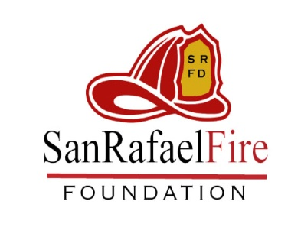
FOR FOUNDATION USE ONLY
Grant Number:

Approved:
Denied:

SAN RAFAEL FIRE FOUNDATION
Grant Request Form

Date: |  | Amount Requested:
Contact Name: |  | Phone:
eMail:

Type of funding request (name of program or equipment):

Provide a brief description and the need for the program/equipment/service (use attachment if needed):

Is there a fiscal impact to approving this request? (Maintenance costs, monthly service cost, extra equipment or services etc.). Please describe:

Has this program/equipment/service previously been requested through the city budget?
If yes, list the most recent date of submission and the result:
If no, explain the reason why it was not submitted:
Has this program/equipment/service been submitted to any other grant provider? If Yes, explain.
What objectives will be accomplished if the funding is granted?

Authorizing Signature _____________________________________
Please attach an itemized list for the expenses or a quote from the equipment manufacturer on the vendor’s letterhead including model numbers and total units needed. Upon approval, the foundation will pay the vendor directly.
Any questions regarding Foundation procedures can be directed to the San Rafael Fire Department at 415-nnn-nnnn.
You may submit your request by email to jdevlin@srfirefoundation.org

